|  |
| --- |
| The BioMechs |
| FRC-2014 Electronic Definition |
| Document Rev: 1 |
|  |
| **Electrical Engineer: Joshua Quintero** |
| **12/29/2014** |

|  |
| --- |
| This document may contain confidential information that is legally privileged. If you are not the intended recipient, or a person responsible for delivering it to the intended recipient, you are hereby notified that any disclosure, copying, distribution or use of any of the information contained in or attached to this document is STRICTLY PROHIBITED. If you have received this in error, please immediately destroy this document and its attachments without reading or saving in any manner. Thank you. |

Comet

I. Summary 3

II. Robot 4

2.1 Definition 4

2.2 Issues and Improvements 4

III. Controller Definition 4

3.1 Driver Controller 4

3.2 Co-Driver Controller 5

IV. Electronics 7

4.1 Sensors Used 7

# Summary

This document is used for definition of the FRC-2014 robot named Comet. Below shows information of Joystick definitions, electronic sensors used, and wiring table.

**Highlights:**

1. Quadrature encoders worked very well. Encoders kept on getting damaged due to loose components. Recommended to make housing for protection.
2. IR Proximity sensor worked well. Place black tape on item being sense to get consistent results.
3. String pot string kept on breaking. Housing got lose. Not good for fast puling force as is. Need stronger housing and string to get reliable sensor for catapult.

# Robot

## Definition

* + 1. **Definition List**

## Issues and Improvements

* + 1. **Issues and Improvements List**

# Controller Definition

## Driver Controller

* + 1. **Driver Controller – Top Side**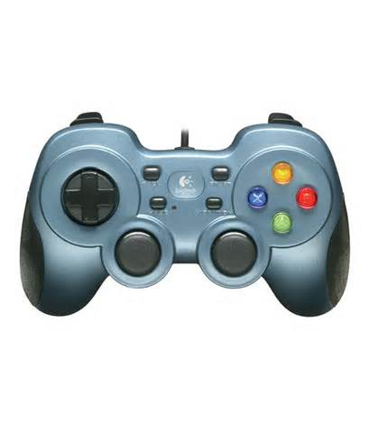

Shift to Low Gear

Shift to high gear

Forward/Back Joystick Y-Axis

Rotate Joystick X-Axis

* + 1. **Driver Controller – Front Side**

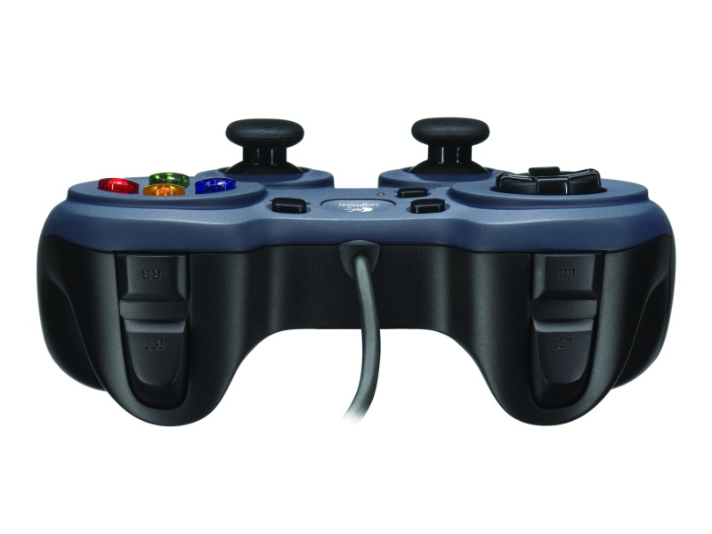

Auto Turn Left 90 deg

Auto Turn Around

Auto Turn Right 90 deg

Quick Turn

* + 1. **Driver Controller – Bottom side**

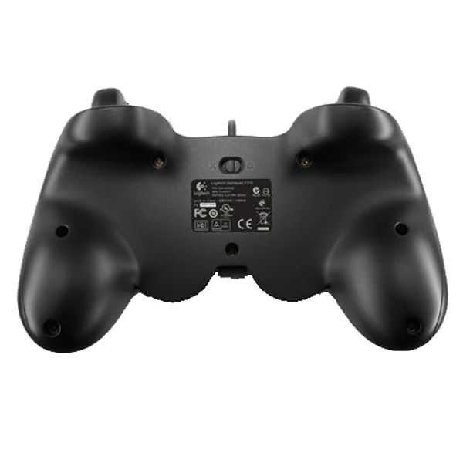

Set Switch to D

## Co-Driver Controller

* + 1. **Co-Driver Controller – Top Side**

Expel ball from back side

Stop Front intake rollers

Deploy Catapult when ball is not present

* + 1. **Co-Driver Controller – Front Side**



Cock Catapult

* + 1. **Co-Driver Controller – Bottom side**



# Electronics

## Sensors Used

* + 1. **Quadrature Encoder** –US Digital (S4-250-250-N-S-B) –Qty 2

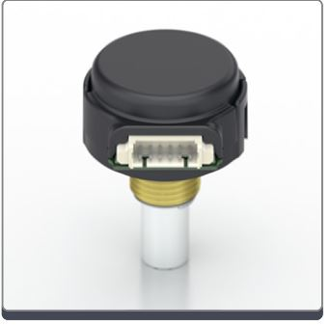

* + 1. **Potentiometer and String assembly** – String Potentiometer Kit (am-2674) – Qty 1

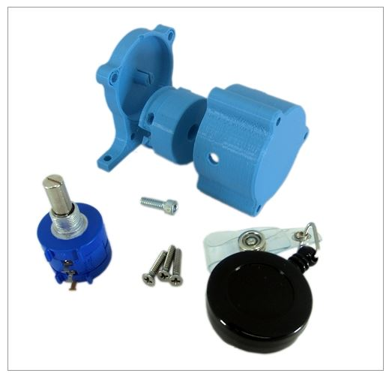

* + 1. **IR proximity switch** - (RKI-1195) – Qty 3

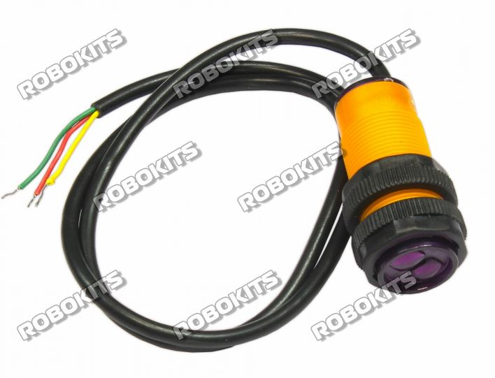

* + 1. **Ultrasonic Proximity Sensor** - (am-2435) – Qty 1

